6.1. Time Complexity of Nearest Neighbor
The Nearest Neighbor algorithm operates on a greedy approach. For a dataset of n locations, the algorithm iterates through all unvisited nodes to find the closest one. This requires an outer loop running n times and an inner lookup running up to n times, resulting in a theoretical time complexity of T(n) = $c_{.}n^{2}$ ,which belongs to $O\left(n^{2}\right)$.
6.2. Time Complexity of Dynamic Programming
The Held-Karp algorithm solves the TSP exactly using memoization. It evaluates all possible subsets of vertices. The number of sub-problems is defined by$n.2^{n}$, and solving each sub-problem takes O(n) time. Therefore, the total time complexity is T(n) = $C.n^{2}2^{n}$ , which belongs to $O\left(n^{2}2^{n}\right)$
6.3. Space Complexity
For the Nearest Neighbor, the space complexity is O(n) as it only requires storing the coordinate arrays. Conversely, the Dynamic Programming approach requires storing the lookup table for memoization, resulting in an exponential space complexity of $O\left(n2^{n}\right)$.

7.Experimental Results & Comparative Analysis
7.1Execution Time Comparison
As part of the empirical analysis, the execution time of the algorithms was measured across different input sizes (n). As shown in Table 1, the Nearest Neighbor algorithm demonstrates efficient and stable runtime, making it highly scalable for large datasets. In contrast, the Dynamic Programming (Held-Karp) algorithm exhibits exponential growth, rendering it impractical for larger values of n.

Table 1: Runtime Performance Comparison (in milliseconds)
Input Size (n) | Nearest Neighbor (ms) | Dynamic Programming (ms)
5 | 0.91 | 0.10
10 | 1.29 | 10.42
15 | 2.85 | 96.52
20 | 12.30 | > 1000 (Explosive Growth)

7.2.Solution Quality (Path Length)
Beyond execution time, the quality of the solution (total route distance) is a critical metric. Table 2 provides a comprehensive comparison of the design paradigms, theoretical complexities, and optimality of the implemented algorithms. While Dynamic Programming guarantees the absolute optimal short path, Nearest Neighbor offers a near-optimal solution with significantly higher scalability.
Table 2: Comprehensive Algorithmic Comparison
Path Optimality | Performance on 10k Data | Time Complexity (Theoretical) | Design  Paradigm | Algorithm
Near-Optimal | Extremely Fast | $$O{\left(n\right)}^{2}$$ | Greedy | Nearest Neighbor
Absolute Optimal | Very Slow (Limited n) | $$O\left(n^{2}2^{n}\right)$$ | Held-Karp | Dynamic Programming
N/A (Grouping Only) | Fast Pre-processing | $$O\left(n.k.ⅈ.d\right)$$ | Unsupervised | K-Means  Clustering

7.3.Visualization of Routes
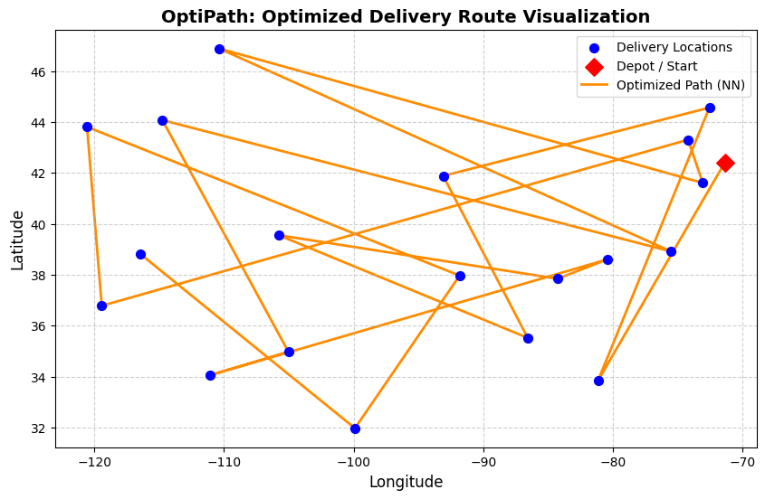
Figure 1: Visualization of the optimized delivery path generated by the Nearest Neighbor algorithm, showing the sequence of nodes and the minimized distance between points.

